HRMS – Human Resource Management System
Version: 1.0
Date: 2025-04-29
Author(s): Rex Tyron Dianela and Team
Organization: SEPTEM INC.

Table of Contents
1. Introduction................................................................................ 1
2. Overall Description..................................................................... 2
3. Architecture & Design................................................................. 3
4. Data Design............................................................................. 4
5. Functional Requirements............................................................. 5
6. External Interface Requirements................................................ 6
7. Non-Functional Requirements.................................................. 7
8. Appendices................................................................................ 8

1. Introduction

1.1 Purpose
This documentation describes the HR Connect system developed as part of the SIA project. It is intended for developers, testers, instructors, and future maintainers to understand the architecture, functionality, and operation of the system.

1.2 Scope
HR Connect is a standalone HR management solution for handling onboarding, payroll, feedback, employee services, and admin-level HR operations, with a user-friendly web interface.

1.3 Definitions, Acronyms & Abbreviations
- HR: Human Resources
- UI: User Interface
- SIA: Systems Integration and Architecture
- HTML/CSS: Web development languages used for the front-end

1.4 References
Team source files (HTML, CSS)
Client-side prototypes and mockups

1.5 Overview of Remainder
The document outlines system features, architecture, data design (if applicable), interface specs, and both functional and non-functional requirements.

2. Overall Description

2.1 Product Perspective
HR Connect is designed as a client-side, standalone HTML-based system. It does not currently include a backend or database but simulates a full HR experience for demonstration purposes.

2.2 Product Functions
- Welcome Page with mission statement
- Admin Login Page
- Service Modules:
- Support Center
- Employee Onboarding
- Feedback & Follow-up
- Payroll Management
- Employee Training
- Benefits Administration
- Contact Page with team details

2.3 User Classes & Characteristics
- Admin: Access to admin-only controls
- Employee/Visitor: Can explore services and contact page

2.4 Operating Environment
Client-side web app (no server needed)
Supported Browsers: Chrome, Edge, Firefox
OS: Windows/macOS/Linux with modern browser

2.5 Design & Implementation Constraints
Front-end built with HTML and CSS only
No dynamic backend or user authentication stored
Admin password is local and static

2.6 Assumptions & Dependencies
System is assumed to be run locally from a browser
No internet or external libraries required

3. Architecture & Design

3.1 System Architecture Diagram
This is a static client-side flow: Home Page → Services → Contact → Admin Login.

3.2 Module Decomposition
- Home Module
- Services Module
- Contact Module
- Admin Module

3.3 Component Descriptions
Home Module
Purpose: Welcomes users, navigation
Responsibilities: Presents sign-in access
Key Components: HTML/CSS only
Services Module
Purpose: Lists six core HR services
Responsibilities: Inform users of service features
Key Components: Static content blocks
Contact Module
Purpose: Displays contact info and team members
Responsibilities: Provide outreach options
Key Components: Static layout with images and text
Admin Login
Purpose: Password-gated page for admin
Responsibilities: Simulate authentication interface
Key Components: HTML form

4. Data Design
As this is a static front-end system, there is no backend or database.
Mockups or schema could be defined for future database planning.

5. Functional Requirements
ID | Requirement Description | Priority | Acceptance Criteria
FR-1 | User can access service information | High | All 6 services are viewable
FR-2 | User can view contact details of the team | High | Contact info and photos displayed correctly
FR-3 | Admin login should accept password input | Medium | Input accepted and login feedback displayed
FR-4 | System should run offline | High | No internet required for navigation

6. External Interface Requirements

6.1 User Interfaces
Pages: Home, Services, Contact, Admin Login
Fully responsive and styled with CSS

6.2 Hardware Interfaces
Not applicable

6.3 Software Interfaces
Not applicable

6.4 Communications Interfaces
Contact via provided email and number (static text)

7. Non-Functional Requirements
- Performance: Immediate response; fully static
- Security: No real authentication; local-only password field
- Usability: User-friendly layout and navigation
- Reliability: Page content always loads (as static HTML)
- Maintainability: Easy to edit/update with basic HTML knowledge
- Scalability: Can be extended with JavaScript or backend in the future

Appendices

Appendix A: System Screenshots

Home Page
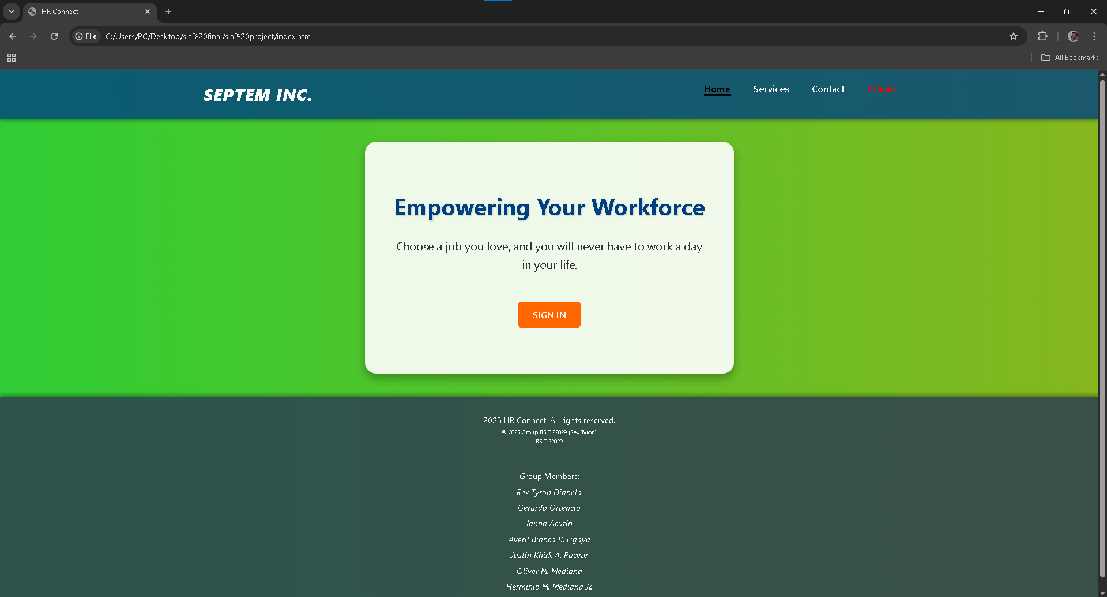

Services Page
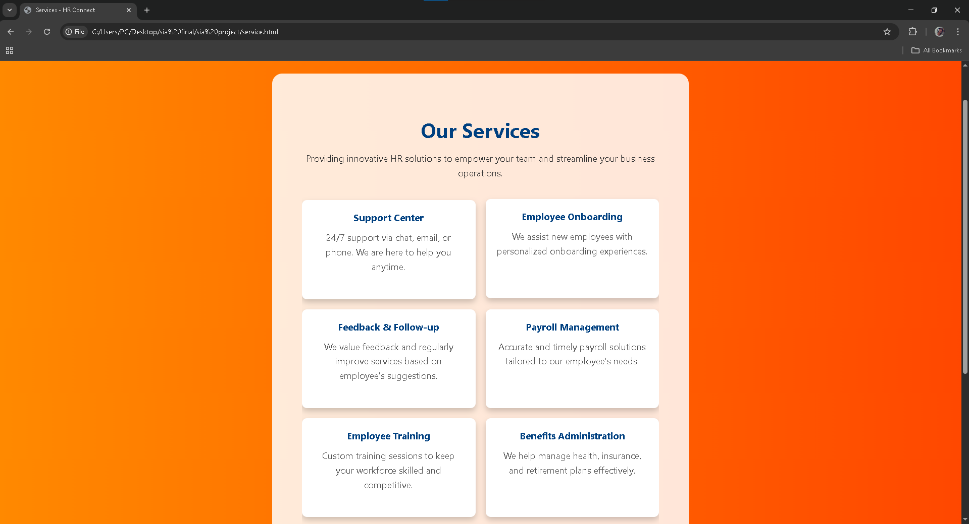

Contact Page
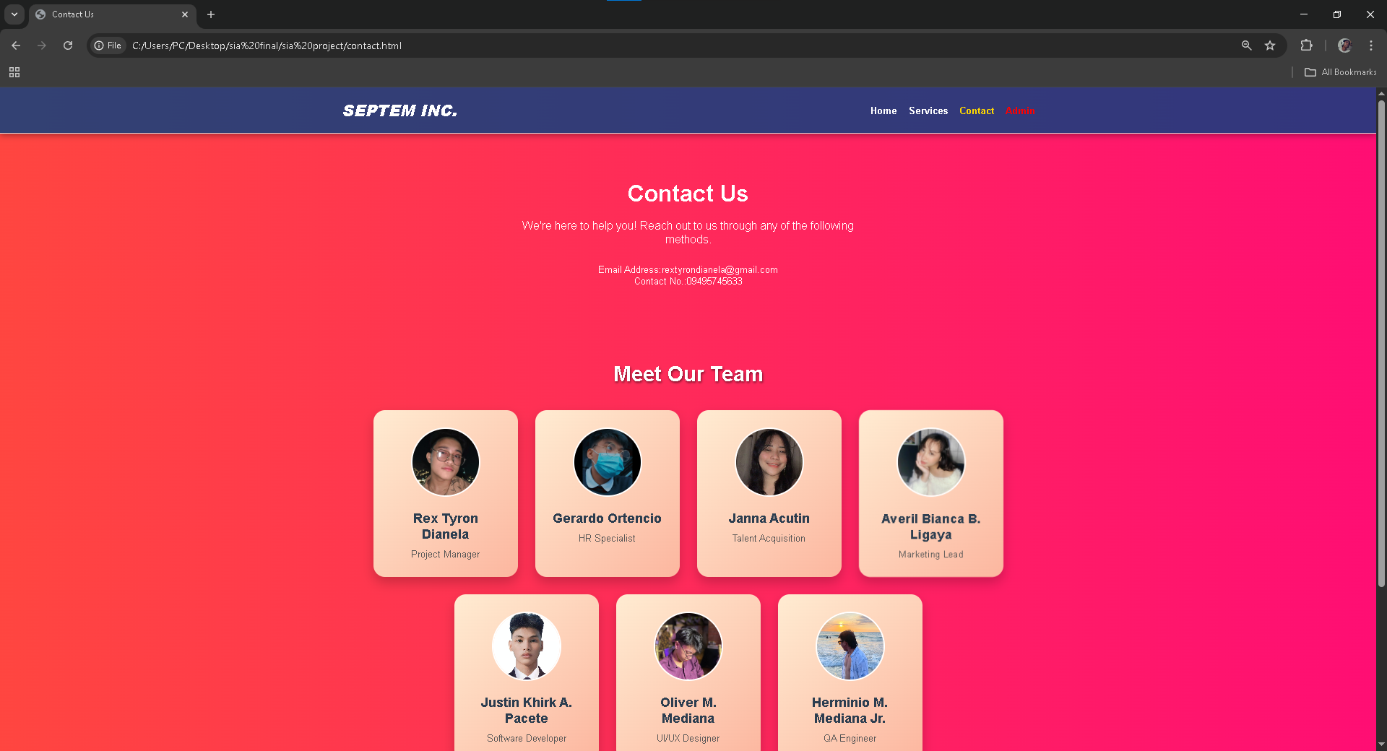

Admin Login Page
